**Fresh concrete**

Fresh concrete or plastic concrete is a freshly mixed material which can be moulded into any shape. The relative quantities of cement, aggregates and water mixed together, control the properties of concrete in the wet state as well as in the hardened state.

We have discussed the role of water and the quantity of water required for chemical combination with cement and to occupy the gel pores. We have seen that the theoretical water/cement ratio required for these two purposes is about 0.38. Use of water/cement ratio more than this, will result in capillary cavities; and less than this, will result in incomplete hydration and also lack of space in the system for the development of gel.

In this chapter one more aspect for deciding the water/cement ratio will be introduced i.e., the water/cement ratio required from the point of view of workability of concrete.

***Workability***

* A theoretical water/cement ratio calculated from the considerations is not going to give an ideal situation for maximum strength. Hundred per cent compaction of concrete is an important parameter for contributing to the maximum strength.
* Lack of compaction will result in air voids whose damaging effect on strength and durability is equally or more predominant than the presence of capillary cavities.
* To enable the concrete to be fully compacted with given efforts, normally a higher water/ cement ratio than that calculated by theoretical considerations may be required. That is to say the function of water is also to lubricate the concrete so that the concrete can be compacted with specified effort forthcoming at the site of work. The lubrication required for handling concrete without segregation, for placing without loss of homogeneity, for compacting with the amount of efforts forth-coming and to finish it sufficiently easily. The quality of concrete satisfying the above requirements is termed as workable concrete.

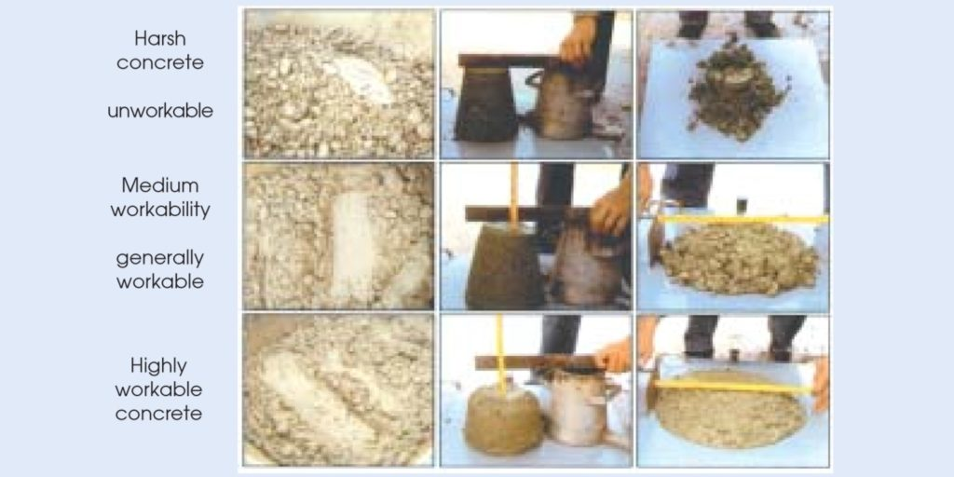

* For a concrete technologist, a comprehensive knowledge of workability is required to design a mix. Workability is a parameter, a mix designer is required to specify in the mix design process, with full understanding of the type of work, distance of transport, loss of slump, method of placing, and many other parameters involved. Assumption of right workability with proper understanding backed by experience will make the concreting operation economical and durable.

***Factors Affecting Workability***

Workable concrete is the one which exhibits very little internal friction between particle and particle or which overcomes the frictional resistance offered by the formwork surface or reinforcement contained in the concrete with just the amount of compacting efforts forthcoming. The factors helping concrete to have more lubricating effect to reduce internal friction for helping easy compaction are given below:

1. **Water Content:**

* Water content in a given volume of concrete, will have significant influences on the workability. The higher the water content per cubic meter of concrete, the higher will be the fluidity of concrete, which is one of the important factors affecting workability.
* It should be noted that from the desirability point of view, increase of water content is the last alternative to be taken for improving the workability even in the case of uncontrolled concrete.
* In case, all other steps to improve workability fail, only as last recourse the addition of more water can be considered. More water can be added, provided a correspondingly higher quantity of cement is also added to keep the water/cement ratio constant, so that the strength remains the same.

1. **Mix Proportions:**

* Aggregate/cement ratio is an important factor influencing workability. The higher the aggregate/cement ratio, the leaner is the concrete.
* In lean concrete, less quantity of paste is available for providing lubrication, per unit surface area of aggregate and hence the mobility of aggregate is restrained. On the other hand, in case of rich concrete with lower aggregate/cement ratio, more paste is available to make the mix cohesive and fatty to give better workability.

1. **Size of Aggregate:**

* The bigger the size of the aggregate, the less is the surface area and hence less amount of water is required for wetting the surface and less matrix or paste is required for lubricating the surface to reduce internal friction. For a given quantity of water and paste, bigger size of aggregates will give higher workability.

1. **Shape of Aggregates:**

* The shape of aggregates influences workability in good measure. Angular, elongated or flaky aggregate makes the concrete very harsh when compared to rounded aggregates or cubical shaped aggregates.
* Contribution to better workability of rounded aggregate will come from the fact that for the given volume or weight it will have less surface area and less voids than angular or flaky aggregate. Not only that, being round in shape, the frictional resistance is also greatly reduced.
* This explains the reason why river sand and gravel provide greater workability to concrete than crushed sand and aggregate.

1. **Surface Texture:**

* The influence of surface texture on workability is again due to the fact that the total surface area of rough textured aggregate is more than the surface area of smooth rounded aggregate of same volume.
* Rough textured aggregate will show poor workability and smooth or glassy textured aggregate will give better workability. A reduction of inter particle frictional resistance offered by smooth aggregates also contributes to higher workability.

1. **Grading of Aggregates:**

* This is one of the factors which will have maximum influence on workability. A well graded aggregate is the one which has least amount of voids in a given volume.
* Other factors being constant, when the total voids are less, excess paste is available to give better lubricating effect.
* With excess amount of paste, the mixture becomes cohesive and fatty which prevents segregation of particles.
* Aggregate particles will slide past each other with the least amount of compacting efforts. The better the grading, the less is the void content and higher the workability.

1. **Use of Admixtures:**

* Use of air-entraining agent being surface-active, reduces the internal friction between the particles. They also act as artificial fine aggregates of very smooth surface.
* Similarly, the fine glassy pozzolanic materials, inspite of increasing the surface area, offer better lubricating effects for giving better workability.

***Measurement of Workability***

Some of the tests, measure the parameters very close to workability and provide useful information. The following tests are commonly employed to measure workability.

(a ) Slump Test

(b) Compacting Factor Test

(c ) Flow Test

(d) Kelly Ball Test

(e ) Vee Bee Consistometer Test

**(a ) Slump Test**

* Slump test is the most commonly used method of measuring consistency of concrete which can be employed either in laboratory or at site of work.
* It is not a suitable method for very wet or very dry concrete. It does not measure all factors contributing to workability, nor is it always representative of the placability of the concrete.
* Repeated batches of the same mix, brought to the same slump, will have the same water content and water cement ratio, provided the weights of aggregate, cement and admixtures are uniform and aggregate grading is within acceptable limits.
* Additional information on workability and quality of concrete can be obtained by observing the manner in which concrete slumps.
* Quality of concrete can also be further assessed by giving a few tappings or blows by tamping rod to the base plate. The deformation shows the characteristics of concrete with respect to tendency for segregation.
* The appartus for conducting the slump test essentially consists of a metallic mould in the form of a frustum of a cone having the internal dimensions as under:

Bottom diameter : 20 cm

Top diameter : 10 cm

Height : 30 cm

* The thickness of the metallic sheet for the mould should not be thinner than 1.6 mm.

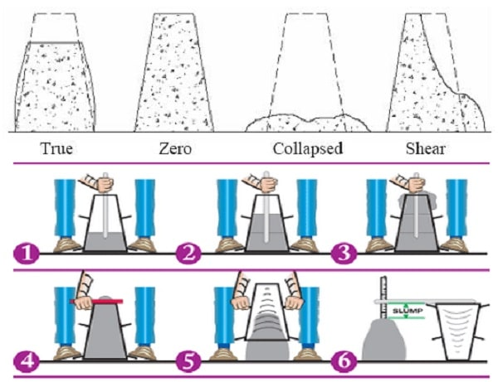

* The pattern of slump is shown in above Fig. It indicates the characteristic of concrete in addition to the slump value.
* If the concrete slumps evenly it is called true slamp. If one half of the cone slides down, it is called shear slump. In case of a shear slump, the slump value is measured as the difference in height between the height of the mould and the average value of the subsidence. Shear slump also indicates that the concrete is non-cohesive and shows the characteristic of segregation.
* It is seen that the slump test gives fairly good consistent results for a plastic-mix. This test is not sensitive for a stiff-mix. In case of dry-mix, no variation can be detected between mixes of different workability. In the case of rich mixes, the value is often satisfactory, their slump being sensitive to variations in workability.
* Despite many limitations, the slump test is very useful on site to check day-to-day or hour to hour variation in the quality of mix.
* An increase in slump may mean for instance that the moisture content of the aggregate has suddenly increased or there has been sudden change in the grading of aggregate. The slump test gives warning to correct the causes for change of slump value.

**(b) Compacting Factor Test**

* The compacting factor test is designed primarily for use in the laboratory but it can also be used in the field. It is more precise and sensitive than the slump test
* It is particularly useful for concrete mixes of very low workability and used when concrete is to be compacted by vibration.
* The compacting factor test has been developed at the Road Research Laboratory U.K. and it is claimed that it is one of the most efficient tests for measuring the workability of concrete.
* This test works on the principle of determining the degree of compaction achieved by a standard amount of work done by allowing the concrete to fall through a standard height.
* The degree of compaction, called the compacting factor is measured by the density ratio i.e., the ratio of the density actually achieved in the test to density of same concrete fully compacted.

**The Compacting Factor =Weight of partially compacted concrete / Weight of fully compacted concrete**

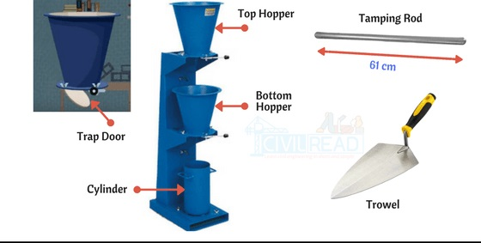

* The sample of concrete to be tested is placed in the upper hopper up to the brim. The trap-door is opened so that the concrete falls into the lower hopper. Then the trap-door of the lower hopper is opened and the concrete is allowed to fall into the cylinder.
* In the case of a dry-mix, it is likely that the concrete may not fall on opening the trap-door. In such a case, a slight poking by a rod may be required to set the concrete in motion.
* The excess concrete remaining above the top level of the cylinder is then cut off with the help of plane blades supplied with the apparatus. The outside of the cylinder is wiped clean. The concrete is filled up exactly upto the top level of the cylinder. It is weighed to the nearest 10 grams. This weight is known as “Weight of partially compacted concrete”.
* The cylinder is emptied and then refilled with the concrete from the same sample in layers approximately 5 cm deep. The layers are heavily rammed or preferably vibrated so as to obtain full compaction. The top surface of the fully compacted concrete is then carefully struck off level with the top of the cylinder and weighed to the nearest 10 gm. This weight is known as “Weight of fully compacted concrete”.
* The weight of fully compacted concrete can also be calculated by knowing the proportion of materials, their respective specific gravities, and the volume of the cylinder.

**(c) Flow Test**

* This is a laboratory test, which gives an indication of the quality of concrete with respect to consistency, cohesiveness and the proneness to segregation. In this test, a standard mass of concrete is subjected to jolting.
* The spread or the flow of the concrete is measured and this flow is related to workability.
* low table made of metal having thickness 1.5mm and dimensions 750mmx 750mm, tamping rod made of hardwood, Scoop, Centimeter Scale, Metal Cone or mould (Lower Dia = 20cm, upper Dia = 13 cm, Height of Cone = 20cm). The middle portion of flow table is marked with a concentric circle of dia 200mm to place a metal cone on it. A lift handle

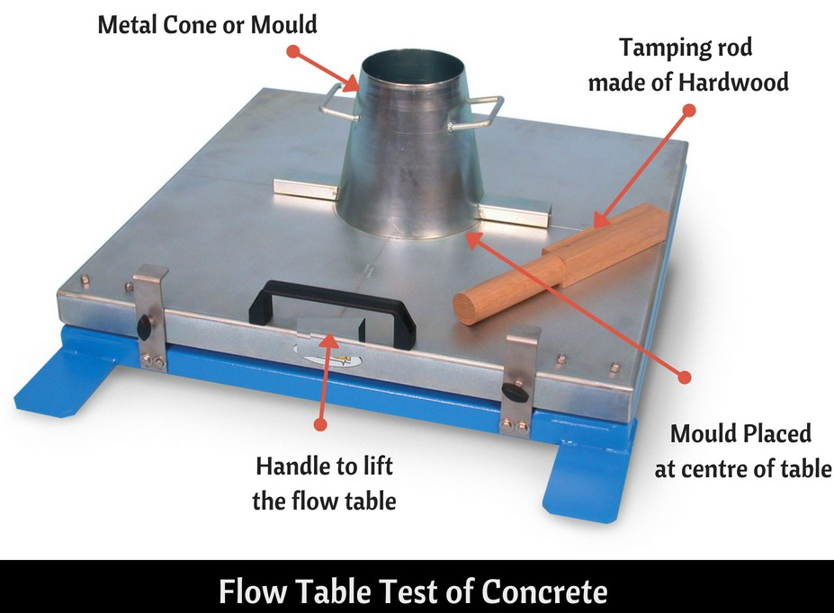

* Prepare concrete as per mix design and place the flow table on a horizontal surface.
* Clean the dust or other gritty material on Flow table and Sprinkle a hand of water on it.
* Now place the metal cone at the middle portion of the flow table and stand on it.
* Pour the freshly mixed concrete in the mould comprising two layers; each layer should be tamped with tamping rod for 25times. After tamping the last layer, the overflowed concrete on the cone is struck off using a trowel.
* Slowly, lift the mould vertically up & let concrete stand on its own without any support.
* The flow table is raised at the height of 12.5mm and dropped. The same is repeated for 15times in 15secs.
* Measure the spread of concrete in Diameter using centimetre scale horizontally and vertically. The arithmetic mean of the two diameters shall be the measurement of flow in millimetres.

**(d) Vee Bee Consistometer Test**

* This is a good laboratory test to measure indirectly the workability of concrete. This test consists of a vibrating table, a metal pot, a sheet metal cone, a standard iron rod.
* Slump test as described earlier is performed, placing the slump cone inside the sheet metal cylindrical pot of the consistometer. The glass disc attached to the swivel arm is turned and placed on the top of the concrete in the pot. The electrical vibrator is then switched on and simultaneously a stop watch started. The vibration is continued till such a time as the conical shape of the concrete disappears and the concrete assumes a cylindrical shape. This can be judged by observing the glass disc from the top for disappearance of transparency.
* Immediately when the concrete fully assumes a cylindrical shape, the stop watch is switched off. The time required for the shape of concrete to change from slump cone shape to cylindrical shape in seconds is known as Vee Bee Degree.
* This method is very suitable for very dry concrete whose slump value cannot be measured by Slump Test, but the vibration is too vigorous for concrete with a slump greater than about 50 mm.

***Segregation and bleeding***

1. **Segregation-**

* Segregation of concrete is the separation of cement paste and aggregates of concrete from each other during handling and placement.
* A good concrete is one in which all the ingredients are properly distributed to make a homogeneous mixture. If a sample of concrete exhibits a tendency for separation of say, coarse aggregate from the rest of the ingredients, then, that sample is said to be showing the tendency for segregation. Such concrete is not only going to be weak; lack of homogeneity is also going to induce all undesirable properties in the hardened concrete.
* There are considerable differences in the sizes and specific gravities of the constituent ingredients of concrete. Therefore, it is natural that the materials show a tendency to fall apart.
* A well made concrete, taking into consideration various parameters such as grading, size, shape and surface texture of aggregate with optimum quantity of waters makes a cohesive mix. Such concrete will not exhibit any tendency for segregation.
* The cohesive and fatty characteristics of matrix do not allow the aggregate to fall apart, at the same time, the matrix itself is sufficiently contained by the aggregate. Similarly, water also does not find it easy to move out freely from the rest of the ingredients.
* Insufficiently mixed concrete with excess water content shows a higher tendency for segregation.
* Dropping of concrete from heights as in the case of placing concrete in column concreting will result in segregation.
* When concrete is discharged from a badly designed mixer, or from a mixer with worn out blades, concrete shows a tendency for segregation.
* Conveyance of concrete by conveyor belts, wheel barrow, long distance haul by dumper, long lift by skip and hoist are the other situations promoting segregation of concrete.
* Vibration of concrete is one of the important methods of compaction. It should be remembered that only comparatively dry mix should be vibrated. It too wet a mix is excessively vibrated, it is likely that the concrete gets segregated. It should also be remembered that vibration is continued just for required time for optimim results. If the vibration is continued for a long time, particularly, in too wet a mix, it is likely to result in segregation of concrete due to settlement of coarse aggregate in matrix.
* Segregation affects the homogeneity of concrete and reduces the strength of concrete. Harmful effects of segregation of concrete include honeycombing in concrete, poor surface finish, reduced strength, reduction in permeability and leakage, crack formation, etc.
* Segregation can be remedied by correctly proportioning the mix, by proper handling, transporting, placing, compacting and finishing. At any stage, if segregation is observed, remixing for a short time would make the concrete again homogeneous.
* A cohesive mix would reduce the tendency for segregation. For this reason, use of certain workability agents and pozzolanic materials greatly help in reducing segregation. The use of air-entraining agent appreciably reduces segregation.

1. **Bleeding**

* Bleeding is sometimes referred as water gain. It is a particular form of segregation, in which some of the water from the concrete comes out to the surface of the concrete, being of the lowest specific gravity among all the ingredients of concrete.
* Bleeding is predominantly observed in a highly wet mix, badly proportioned and insufficiently mixed concrete. In thin members like roof slab or road slabs and when concrete is placed in sunny weather show excessive bleeding.
* Due to bleeding, water comes up and accumulates at the surface. Sometimes, along with this water, certain quantity of cement also comes to the surface. When the surface is worked up with the trowel and floats, the aggregate goes down and the cement and water come up to the top surface. This formation of cement paste at the surface is known as “Laitance”.
* If laitance is formed on a particular lift, a plane of weakness would form and the bond with the next lift would be poor. This could be avoided by removing the laitance fully before the next lift is poured.
* Water while traversing from bottom to top, makes continuous channels. If the water cement ratio used is more than 0.7, the bleeding channels will remain continuous and unsegmented by the development of gel. These continuous bleeding channels are often responsible for causing permeability of the concrete structures.
* The accumulation of water creates water voids and reduces the bond between the aggregates and the paste.
* Bleeding can be reduced by proper proportioning and uniform and complete mixing. Use of finely divided pozzolanic materials reduces bleeding by creating a longer path for the water to traverse.
* It is also reported that the bleeding can be reduced by the use of finer cement or cement with low alkali content. Rich mixes are less susceptible to bleeding than lean mixes.
* The bleeding is not completely harmful if the rate of evaporation of water from the surface is equal to the rate of bleeding. Removal of water, after it had played its role in providing workability, from the body of concrete by way of bleeding will do good to the concrete.
* Bleeding presents a very serious problem when Slip Form Paver is used for construction of concrete pavements. If two much of bleeding water accumulates on the surface of pavement slab, the bleeding water flows out over the unsupported sides which causes collapsing of sides.

**Bleeding water percentage =Total quantity of bleeding water/Total quantity of water in the sample of concrete x 100**

***Process of Manufacture of Concrete***

Production of quality concrete requires meticulous care exercised at every stage of manufacture of concrete. It is interesting to note that the ingredients of good concrete and bad concrete are the same. If meticulous care is not exercised, and good rules are not observed, the resultant concrete is going to be of bad quality. With the same material if intense care is taken to exercise control at every stage, it will result in good concrete. Therefore, it is necessary for us to know what are the good rules to be followed in each stage of manufacture of concrete for producing good quality concrete. The various stages of manufacture of concrete are:

1. **Batching**

The measurement of materials for making concrete is known as batching. There are two methods of batching:

1. ***Volume batching:***

* Volume batching is not a good method for proportioning the material because of the difficulty it offers to measure granular material in terms of volume. Volume of moist sand in a loose condition weighs much less than the same volume of dry compacted sand.
* Cement is always measured by weight. It is never measured in volume. Generally, for each batch mix, one bag of cement is used. The volume of one bag of cement is taken as thirty five (35) litres.
* Gauge boxes are used for measuring the fine and coarse aggregates. They can be made of timber or steel plates.

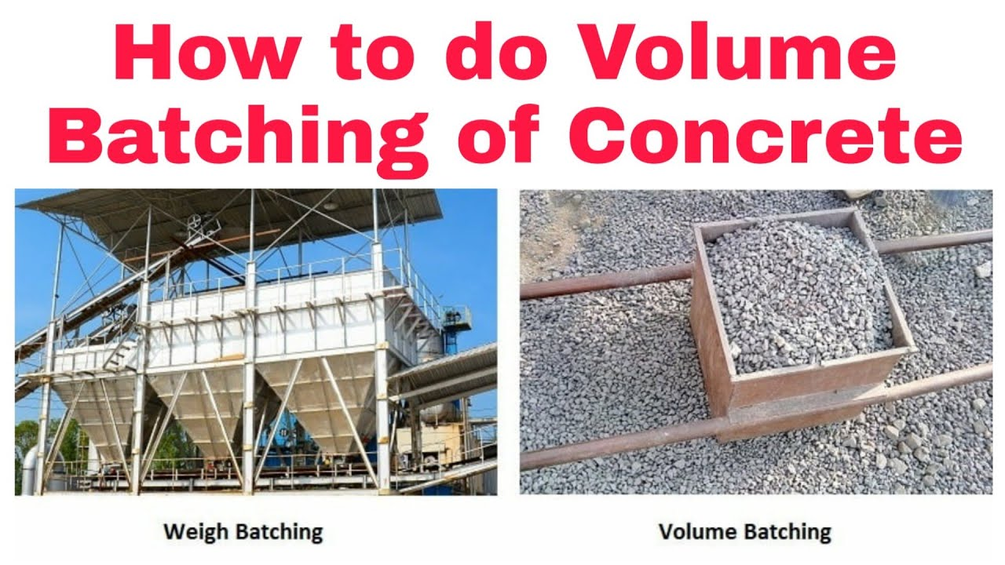

* Water is measured either in kg. or litres as may be convenient. In this case, the two units are same, as the density of water is one kg. per litre.

1. ***Weigh Batching:***

* Strictly speaking, weigh batching is the correct method of measuring the materials. For important concrete, invariably, weigh batching system should be adopted.
* Use of weight system in batching, facilitates accuracy, flexibility and simplicity.
* Different types of weigh batchers are available, the particular type to be used, depends upon the nature of the job. Large weigh batching plants have automatic weighing equipment.
* On large work sites, the weigh bucket type of weighing equipments is used. Automatic batching plants are available in small or large capacity.
* In some of the recent automatic weigh batching equipments, recorders are fitted which record graphically the weight of each material, delivered to each batch. They are meant to record, and check the actual and designed proportions.
* Aggregate weighing machines require regular attention if they are to maintain their accuracy. Check calibrations should always be made by adding weights in the hopper equal to the full weight of the aggregate in the batch. The error found is adjusted from time to time.

1. **Mixing**

Thorough mixing of the materials is essential for the production of uniform concrete. The mixing should ensure that the mass becomes homogeneous, uniform in colour and consistency. There are two methods adopted for mixing concrete:

1. ***Hand Mixing:***

* Hand mixing is practised for small scale unimportant concrete works. As the mixing cannot be thorough and efficient, it is desirable to add 10 per cent more cement to cater for the inferior concrete produced by this method.
* Hand mixing should be done over an impervious concrete or brick floor of sufficiently large size to take one bag of cement.
* Spread out the measured quantity of coarse aggregate and fine aggregate in alternate layers. Pour the cement on the top of it, and mix them dry by shovel, turning the mixture over and over again until uniformity of colour is achieved.
* This uniform mixture is spread out in thickness of about 20 cm. Water is taken in a water-can fitted with a rose-head and sprinkled over the mixture and simultaneously turned over.
* This operation is continued till such time a good uniform, homogeneous concrete is obtained. It is of particular importance to see that the water is not poured but it is only sprinkled.

1. ***Machine Mixing:***

* Machine mixing is not only efficient, but also economical, when the quantity of concrete to be produced is large.
* Many types of mixers are available for mixing concrete. They can be classified as batch-mixers and continuous mixers. Batch mixers produce concrete, batch by batch with time interval.
* Continuous mixers produce concrete continuously without stoppage till such time the plant is working. In this, materials are fed continuously by screw feeders and the materials are continuously mixed and continuously discharged. This type of mixers is used in large works such as dams. In normal concrete work, it is the batch mixers that are used.
* The drum type may be further classified as tilting, non-tilting, reversing or forced action type. It is seen that tilting drum to some extent is more efficient than non-tilting drum.
* Concrete mixers are generally designed to run at a speed of 15 to 20 revolutions per minute.
* It is seen from the experiments that the quality of concrete in terms of compressive strength will increase with the increase in the time of mixing, but for mixing time beyond two minutes, the improvement in compressive strength is not very significant.
* The process of remixing of concrete, if necessary, with addition of just the required quantity of water is known as “Retempering of Concrete”. Sometimes, a small quantity of extra cement is also added while retempering.
* The drum and blades must be kept absolutely clean at the end of concreting operation.

1. **Transporting Concrete**

Concrete can be transported by a variety of methods and equipments. The precaution to be taken while transporting concrete is that the homogeneity obtained at the time of mixing should be maintained while being transported to the final place of deposition.

1. ***Mortar Pan:*** It is labour intensive. In this case, concrete is carried in small quantities. While this method nullifies the segregation to some extent, particularly in thick members, it suffers from the disadvantage that this method exposes greater surface area of concrete for drying conditions. This results in greater loss of water, particularly, in hot weather concreting and under conditions of low humidity. It is to be noted that the mortar pans must be wetted to start with and it must be kept clean during the entire operation of concreting. Mortar pan method of conveyance of concrete can be adopted for concreting at the ground level, below or above the ground level without many difficulties.
2. ***Wheel Barrow:*** Wheel barrows are normally used for transporting concrete to be placed

at ground level. This method is employed for hauling concrete for comparatively longer distance as in the case of concrete road construction. If concrete is conveyed by wheel barrow over a long distance, on rough ground, it is likely that the concrete gets segregated due to vibration. The coarse aggregates settle down to the bottom and matrix moves to the top surface. To avoid this situation, sometimes, wheel barrows are provided with pneumatic wheel to reduce vibration.

1. ***Crane, Bucket and Rope Way***: A crane and bucket is one of the right equipment for transporting concrete above ground level in high rise construction. Cranes are fast and versatile to move concrete horizontally as well as vertically along the boom and allows the placement of concrete at the exact point.

Rope way and bucket of various sizes are used for transporting concrete to a place, where simple method of transporting concrete is found not feasible. For the concrete works in a valley or the construction work of a pier in the river or for dam construction, this method of transporting by rope way and bucket is adopted. The mixing of concrete is done on the bank or abutment at a convenient place and the bucket is brought by a pulley or some other arrangement. This is one of the methods generally adopted for concreting dam work or bridge work. It should be practised that concrete is discharged from the smallest height possible and should not be made to freely fall from great height.

1. ***Truck Mixer and Dumpers***: For large concrete works particularly for concrete to be placed

at ground level, trucks and dumpers or ordinary open steel-body tipping lorries can be used. As they can travel to any part of the work, they have much advantage over the jubilee wagons, which require rail tracks. Dumpers are of usually 2 to 3 cubic metre capacity, whereas the capacity of truck may be 4 cubic metre or more. Before loading with the concrete, the inside of the body should be just wetted with water. Tarpaulins or other covers may be provided to cover the wet concrete during transit to prevent evaporation. For road construction using Slip Form Paver large quantity of concrete is required to be supplied continuously.

1. ***Belt Conveyors:*** Belt conveyors have very limited applications in concrete construction. The principal objection is the tendency of the concrete to segregate on steep inclines, at transfer points or change of direction, and at the points where the belt passes over the rollers. Another disadvantage is that the concrete is exposed over long stretches which causes drying and stiffening particularly, in hot, dry and windy weather. Segregation also takes place due to the vibration of rubber belt. It is necessary that the concrete should be remixed at the end of delivery before placing on the final position. Modern Belt Conveyors can have adjustable reach, travelling diverter and variable speed both forward and reverse. Conveyors can place large volumes of concrete quickly where access is limited.
2. ***Chute:*** Chutes are generally provided for transporting concrete from ground level to a lower level. The sections of chute should be made of or lined with metal and all runs shall have approximately the same slope, not flatter than 1 vertical to 2 1/2 horizontal.
3. ***Pumps and Pipeline*** Pumping of concrete is universally accepted as one of the main methods of concrete transportation and placing. The hydraulic piston pump is the most widely used modern pump. There are three main types of concrete pump. They are mobile, trailor or static and screed or mortar pump. It is not enough to have an efficient pump. It is equally important to have correct diameter of pipeline with adequate wall thickness for a given operating pressure and well designed coupling system for trouble free operation. A poor pipeline can easily cause blockages arising from leakage of grout. Pushing of abrasive material at high pressure, through pipeline inevitably creates a great deal of wear. Continuous handling, frequent securing and releasing of couplings create wear at joints. All these must be maintained well for trouble free function and safety. It is important to choose the correct diameter and wall thickness of the pipeline to match the pump and required placing rate.

A carefully laid pipeline is the prerequisite for trouble free pumping operation. Time, money and trouble are saved at sites if the installation of concrete pump and the laying of pipelines are thoroughly planned and carried out with care.

Choosing the Correct Pump

For choosing the correct pump one must know the following factors

* Length of horizontal pipe
* Length of vertical pipe
* Number of bends
* Diameter of pipeline
* Length of flexible hose
* Changes in line diameter
* Slump of Concrete

**(d) Placing Concrete**

It is not enough that a concrete mix correctly designed, batched, mixed and transported, it is of utmost importance that the concrete must be placed in systematic manner to yield optimum results. The precautions to be taken and methods adopted while placing concrete in the under-mentioned situations will be discussed.

**(a) Placing concrete within earth mould. (Example: Foundation concrete for a wall or column).**

* Before placing the concrete in the foundation, all the loose earth must be removed from the bed.
* Any root of trees passing through the foundation must be cut, to prevent its further growth and piercing the concrete at a later date.
* The surface of the earth, if dry, must be just made damp so that the earth does not absorb water from concrete.
* On the other hand if the foundation bed is too wet and rain-soaked, the water and slush must be removed completely to expose firm bed before placing concrete.
* If there is any seepage of water taking place into the foundation trench, effective method for diverting the flow of water must be adopted before concrete is placed in the trench or pit.

**(b) Placing concrete within large earth mould or timber plank formwork. (Example: Road slab and Airfield slab).**

* For the construction of road slabs, airfield slabs and ground floor slabs in buildings, concrete is placed in bays.
* The ground surface on which the concrete is placed must be free from loose earth, pool of water and other organic matters like grass, roots, leaves etc.
* The earth must be properly compacted and made sufficiently damp to prevent the absorption of water from concrete.
* Provisions for contraction joints and dummy joints are given.
* It is also to be ensured that concrete must be placed in just required thickness.

**(c ) Placing concrete in layers within timber or steel shutters. (Example: Mass concrete in dam construction or construction of concrete abutment or pier).**

* When concrete is laid in great thickness, as in the case of concrete raft for a high rise building or in the construction of concrete pier or abutment or in the construction of mass concrete dam, concrete is placed in layers.
* The thickness of layers depends upon the mode of compaction.
* In reinforced concrete, it is a good practice to place concrete in layers of about 15 to 30 cm thick and in mass concrete, the thickness of layer may vary anything between 35 to 45 cm.
* The thickness of layer is limited by the method of compaction and size and frequency of vibrator used.

**(d ) Placing concrete within usual from work. (Example: Columns, beams and floors).**

* Firstly, it must be checked that the reinforcement is correctly tied, placed and is having appropriate cover.
* The joints between planks, plywoods or sheets must be properly and effectively plugged so that matrix will not escape when the concrete is vibrated.
* The inside of the formwork should be applied with mould releasing agents for easy stripping. Such purpose made mould releasing agents is separately available for steel or timber shuttering.
* The reinforcement should be clean and free from oil.
* Where reinforcement is placed in a congested manner, the concrete must be placed very carefully, in small quantity at a time so that it does not block the entry of subsequent concrete.
* When the concrete is poured from a height, against reinforcement and lateral ties, it is likely to segregate or block the space to prevent further entry of concrete. To avoid this, concrete is directed by tremie, drop chute.
* Formwork should not be removed until the concrete has developed strength of at least twice the stress to which concrete may be subjected at the time of removal of formwork.

**(e ) Placing concrete under water.**

* In such cases, use of bottom dump bucket or tremie pipe is made use of.
* In the bottom dump bucket concrete is taken through the water in a water-tight box or bucket and on reaching the final place of deposition the bottom is made to open by some mechanism and the whole concrete is dumped slowly.
* In some situations, dry or semi-dry mixture of cement, fine and coarse aggregate are filled in cement bags and such bagged concrete is deposited on the bed below the water.
* The satisfactory method of placing concrete under water is by the use of tremie pipe.

**(e) Compaction of Concrete**

Compaction of concrete is the process adopted for expelling the entrapped air from the concrete. In the process of mixing, transporting and placing of concrete air is likely to get entrapped in the concrete. The lower the workability, higher is the amount of air entrapped. In other words, stiff concrete mix has high percentage of entrapped air and, therefore, would need higher compacting efforts than high workable mixes. If this air is not removed fully, the concrete loses strength considerably.

Insufficient compaction increases the permeability of concrete resulting in easy entry for aggressive chemicals in solution, which attack concrete and reinforcement to reduce the durability of concrete. In order to achieve full compaction and maximum density, with reasonable compacting efforts available at site, it is necessary to use a mix with adequate workability. It is also of common knowledge that the mix should not be too wet for easy compaction which also reduces the strength of concrete.

The following methods are adopted for compacting the concrete:

1. **Hand Compaction**

Hand compaction of concrete is adopted in case of unimportant concrete work of small magnitude. Sometimes, this method is also applied in such situation, where a large quantity of reinforcement is used, which cannot be normally compacted by mechanical means.

(i) Rodding- Rodding is nothing but poking the concrete with about 2 metre long, 16 mm diameter rod to pack the concrete between the reinforcement and sharp corners and edges. Rodding is done continuously over the complete area to effectively pack the concrete and drive away entrapped air. Sometimes, instead of iron rod, bamboos or cane is also used for rodding purpose.

(ii) Ramming- Ramming can be carried out in unreinforced foundation concrete or in small works (ground floor construction). Concrete should be rammed or puddled to force out the entrapped air bubbles at the time of placing of concrete. Ramming of concrete depends upon the concrete slump. If the slump of concrete (water-cement ratio) is high, the aggregates settle down at bottom and cement slurry may appear at the top layer. It may result in poor strength of concrete that may lower the service life of house or building.

(iii) Tamping- Tamping is adopted to compact the roof or floor slab or pavements of RCC road where the thickness of concrete is comparatively less and the surface is to be finished smooth and level. It is done with the wooden cross beam (generally size of beam is about 10 x 10 cm).

1. **Compaction by Vibration**

It is pointed out that the compaction by hand, if properly carried out on concrete with sufficient workability, gives satisfactory results, but the strength of the hand compacted concrete will be necessarily low because of higher water cement ratio required for full compaction. Where high strength is required, it is necessary that stiff concrete, with low water/cement ratio be used. To compact such concrete, mechanically operated vibratory equipment, must be used. The vibrated concrete with low water/cement ratio will have many advantages over the hand compacted concrete with higher water/cement ratio.

(i) Internal vibrator (Needle vibrator)- This essentially consists of a power unit, a flexible shaft and a needle. The vibrations are caused by eccentric weights attached to the shaft or the motor or to the rotor of a vibrating element. The frequency of vibration varies upto 12,000 cycles of vibration per minute. The needle diameter varies from 20 mm to 75 mm and its length varies from 25 cm to 90 cm. The bigger needle is used in the construction of mass concrete dam.

(ii) Formwork vibrator (External vibrator)- Formwork vibrators are used for concreting columns, thin walls or in the casting of precast units. The machine is clamped on to the external wall surface of the formwork. The vibration is given to the formwork so that the concrete in the vicinity of the shutter gets vibrated. This method of vibrating concrete is particularly useful and adopted where reinforcement, lateral ties and spacers interfere too much with the internal vibrator.

(iii ) Table vibrator- This is the special case of formwork vibrator, where the vibrator is clamped to the table. or table is mounted on springs which are vibrated transferring the vibration to the table. They are commonly used for vibrating concrete cubes.

(iv) Platform vibrator- Platform vibrator is nothing but a table vibrator, but it is larger in size. This is used in the manufacture of large prefabricated concrete elements such as electric poles, railway sleepers, prefabricated roofing elements etc.

(v) Surface vibrator (Screed vibrator)- Surface vibrators are sometimes knows as, “Screed Board Vibrators”. A small vibrator placed on the screed board gives an effective method of compacting and levelling of thin concrete members, such as floor slabs, roof slabs and road surface. Mostly, floor slabs and roof slabs are so thin that internal vibrator or any other type of vibrator cannot be easily employed. In such cases, the surface vibrator can be effectively used. In general, surface vibrators are not effective beyond about 15 cm.

(vi)Vibratory Roller- One of the recent developments of compacting very dry and lean concrete is the use of Vibratory Roller. Such concrete is known as Roller Compacted Concrete. This method of concrete construction originated from Japan and spread to USA and other countries mainly for the construction of dams and pavements. Heavy roller which vibrates while rolling is used for the compaction of dry lean concrete.

1. **Concrete Compaction by Spinning**

This method is used for compacting the concrete pipes (RCC Hume Pipe). In this method, the fresh concrete is well compacted by centrifugal force which is generated while spinning process.

1. **Concrete Compaction by Pressure and Jolting**

This compaction method is used for compacting hollow blocks, cavity blocks, concrete blocks. In this method, the stiff concrete is vibrated, pressed, and also given jolts.

**General Points on Using Vibrators-**

* The speed is relatively constant, and the cables supplying current are light and easily handled.
* Small portable petrol engines are sometimes used for vibrating concrete.
* Compressed-air vibrators give trouble especially in cold weather; by freezing at exhaust unless alcohol is trickled into the air line or dry air is used. Glycol type antifreeze agents tend to cause gumming of the vibrator valves. There is also a tendency for moisture to collect in the motor, hence care should be taken to remove the possible damage.
* Care shall be taken that the vibrating head does not come into contact with hard objects like hardened concrete, steel and wood, as otherwise the impact may damage the bearings.
* The size and characteristics of the vibrator suitable for a particular job vary with the concrete mix design, quality and workability of concrete, placing conditions, size and shape of the member and shall be selected depending upon various requirements.
* Correct design of concrete mix and an effective control in the manufacture of concrete, right from the selection of constituent materials through its correct proportioning to its placing, are essential to obtain maximum benefits of vibration. For best results, the concrete to be vibrated shall be of the stiffest possible consistency, generally within a range of 0.75 to 0.85 compacting factor.
* For vibrated concrete, the formwork shall be stronger than is necessary for hand compacted concrete and greater care is exercised in its assembly. It must be designed to take up increased pressure of concrete and pressure variations caused in the neighborhood of the vibrating head which may result in the excessive local stress on the formwork.
* The vibrator may be used vertically, horizontally or at an angle depending upon the nature of the job. But needle vibrators should be immersed in beams and other thick sections, vertically at regular intervals.
* Concrete is placed in thin layers consistent with the method being used to place and vibrate the concrete. Usually concrete shall be placed in a thickness not more than 60 cm and on initial placing in thickness not more than 15 cm.
* To be fully effective, the active part of the vibrator shall be completely immersed in the concrete.
* The points of insertion of the vibrator in the concrete shall be so spaced that the range of action overlap to some extent and the freshly filled concrete is sufficiently compacted everywhere. The range of action varies with the characteristics of the vibrator and the composition and workability of concrete.
* Usually a speed of 3 cm/s gives sufficient consolidation without undue strain on the operator.
* New filling shall be vibrated while the concrete is plastic, preferably within one hour. The duration of vibration in each position of insertion is dependent upon the height of the layer, the size and characteristics of the vibrator and the workability of the concrete mix. It is better to insert the vibrating head at a number of places than to leave it for a long time in one place, as in the latter case, there is a tendency for formation of mortar pocket at the point of insertion of the vibrator.
* The vibrator head shall not be brought very near the formwork as this may cause formation of water whirls (stagnations), especially if the concrete containing too little of fine aggregate.
* The reinforcement should be designed to leave sufficient space for the vibrating head. Where possible, the reinforcement may be grouped so that the width of groups of bars does not exceed 25 cm and a space of 7.5 cm exists between the groups of bars to allow the vibrator to pass freely.
* There is a possibility of over-vibration while trying to achieve thorough vibration, but it is exceedingly unlikely in well proportioned mixes containing normal weight aggregates. Generally, with properly designed mixes, extended vibration will be only a waste of effort without any particular harm to the concrete.

**(f) Curing of Concrete**

The hydration of cement is not a momentary action but a process continuing for long time. Of cource, the rate of hydration is fast to start with, but countinues over a very long time at a decreasing rate. The quantity of the product of hydration and consequently the amount of gel formed depends upon the extent of hydration. A water/cement ratio of about 0.38 would be required to hydrate all the particles of cement and also to occupy the space in the gel pores. Theoretically, for a concrete made and contained in a sealed container a water cement ratio of 0.38 would satisfy the requirement of water for hydration and at the same time no capillary vavities would be left. However, it is seen that practically a water/cement ratio of 0.5 will be required for complete hydration in a sealed container for keeping up the desirable relative humidity level. In the field and in actual work, it is a different story. Even though a higher water/cement ratio is used, since the concrete is open to atmosphere, the water used in the concrete evaporates and the water available in the concrete will not be sufficient for effective hydration to take place particularly in the top layer.

If the hydration is to continue unbated, extra water must be added to replenish the loss of water on account of absorption and evaporation. Alternatively, some measures must be taken by way of provision of impervious covering or application of curing compounds to prevent the loss of water from the surface of the concrete. Therefore, the curing can be considered as creation of a favourable environment during the early period for uninterrupted hydration. Curing can also be described as keeping the concrete moist and warm enough so that the hydration of cement can continue.

Curing methods may be divided broadly into four categories:

(a)Water curing- This is by far the best method of curing as it satisfies all the requirements of curing, namely, promotion of hydration, elimination of shrinkage and absorption of the heat of hydration. Water curing can be done in the following ways: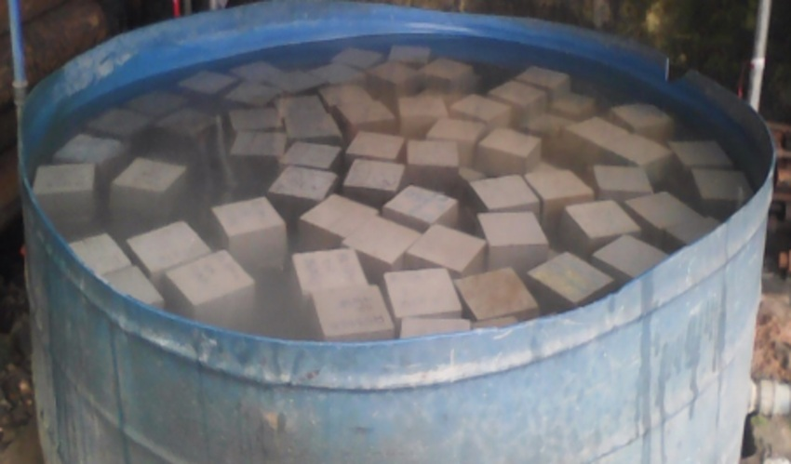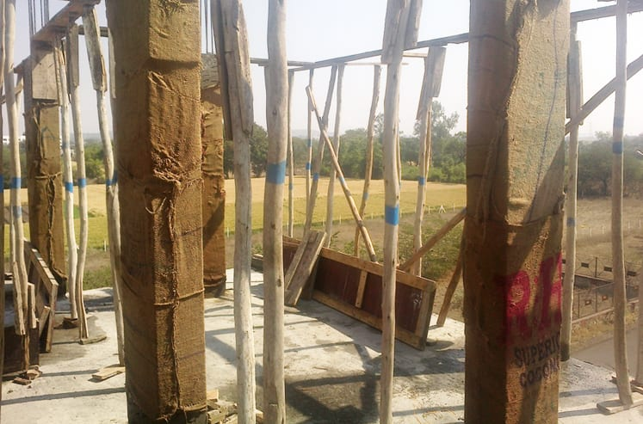

Immersion Curing Wet covering method

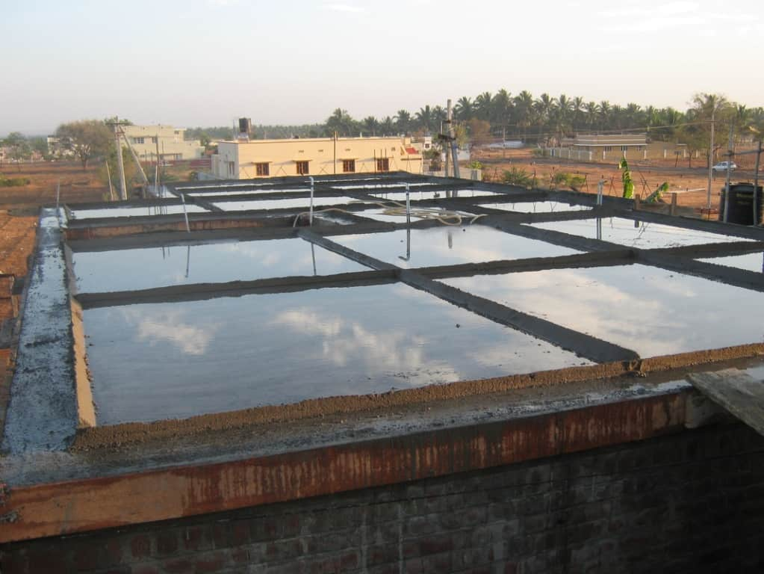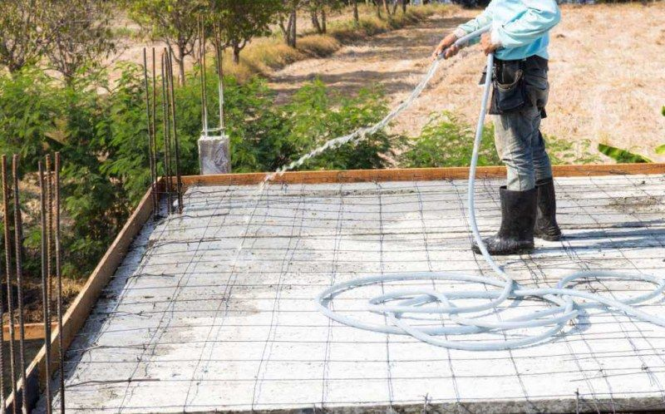

Ponding Spraying or Fogging

The precast concrete items are normally immersed in curing tanks for certain duration. Pavement slabs, roof slab etc. are covered under water by making small ponds. Vertical retaining wall or plastered surfaces or concrete columns etc. are cured by spraying water. In some cases, wet coverings such as wet gunny bags, hessian cloth, jute matting, straw etc., are wrapped to vertical surface for keeping the concrete wet.

(b)Membrane curing- Sometimes, concrete works are carried out in places where there is acute shortage of water. The lavish application of water for water curing is not possible for reasons of economy. It has been pointed out earlier that curing does not mean only application of water, it means also creation of conditions for promotion of uninterrupted and progressive hydration. It is also pointed out that the quantity of water, normally mixed for making concrete is more than sufficient to hydrate the cement, provided this water is not allowed to go out from the body of concrete. For this reason, concrete could be covered with membrane which will effectively seal off the evaporation of water from concrete. It is found that the application of membrane or a sealing compound, after a short spell of water curing for one or two days is sometimes beneficial.

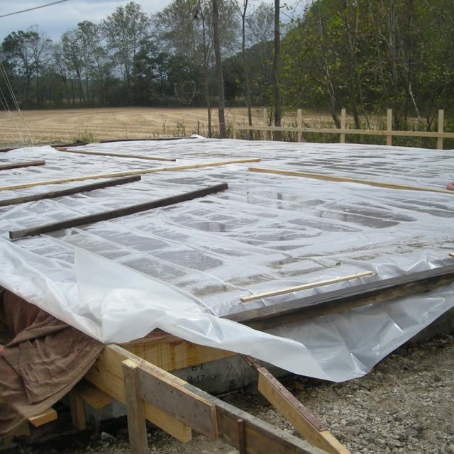

(c) Application of heat- The development of strength of concrete is a function of not only time but also that of temperature. When concrete is subjected to higher temperature it accelerates the hydration process resulting in faster development of strength. Concrete cannot be subjected to dry heat to accelerate the hydration process as the presence of moisture is also an essential requisite. Therefore, subjecting the concrete to higher temperature and maintaining the required wetness can be achieved by subjecting the concrete to steam curing.

The exposure of concrete to higher temperature is done in the following manner:

* Steam curing at ordinary pressure- This method of curing is often adopted for pefabricated concrete elements.
* Steam curing at high pressure- In the steam curing at atmospheric pressure, the temperature of the steam is naturally below 100°C. The steam will get converted into water, thus it can be called in a way, as hot water curing. This is done in an open atmosphere. The high pressure steam curing is something different from ordinary steam curing, in that the curing is carried out in a closed chamber. The superheated steam at high pressure and high temperature is applied on the concrete. This process is also called “Autoclaving”. The autoclaving process is practiced in curing precast concrete products in the factory, particularly, for the lightweight concrete products.
* Curing by Infra-red radiation- Curing of concrete by Infra-red Radiation has been practised in very cold climatic regions. It is claimed that much more rapid gain of strength can be obtained than with steam curing and that rapid initial temperature does not cause a decrease in the ultimate strength as in the case of steam curing at ordinary pressure. The system is very often adopted for the curing of hollow concrete products.
* Electrical curing-Another method of curing concrete, which is applicable mostly to very cold climatic regions is the use of electricity. This method is not likely to find much application in ordinary climate owing to economic reasons.

(d) Miscellaneous- Calcium chloride is used either as a surface coating or as an admixture. It has been used satisfactorily as a curing medium.

* The curing should start after minimum six hours (Final setting time of cement) and not less than 24 hours.